INUIT CIRCUMPOLAR COUNCIL (CANADA)

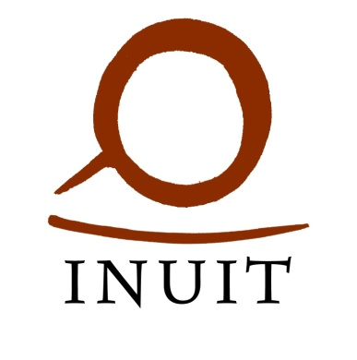
PRESIDENT
CANDIDATE APPLICATION FORM

DEADLINE: 5:00 PM EST, JULY 1, 2026

__________________________________________

Name

__________________________________________
Date of Birth

__________________________________________
Address

__________________________________________
Email
__________________________________________

Signature of Candidate
□ I am an Inuk

□ I am at least 18 years of age

□ Valid criminal record check is attached

□ Photo of passport quality is attached

□ Names of Inuit who support the candidacy (Minimum 20)

□ A brief biography or resume detailing relevant experience is attached (optional)

□ Proof of payment for the deposit in the amount of $200 is attached.

Contact information:

Chief Returning Officer
Inuit Circumpolar Council (Canada)
75 Albert Street, Suite 1001, Ottawa ON K1P 5E7
Ph: (613) 563-2642 / Fax: (613) 565-3089
Email: icc.elections2026@gmail.com

Names of Inuit who support the candidacy (Minimum 20)

Supporter signatures are not required where the candidate is nominated in writing by an ICC Canada Member organization.

 | Name | Phone Number | Land Claim Affiliation | Signature
1.
2.
3.
4.
5.
6.
7.
8.
9.
10.
11.
12.
13.
14.
15.
16.
17.
18.
19.
20.

